Data Warehouse Application (DWA)

The DWA application has been created to demonstrate an example front end for a Data warehouse. As a tutorial it assumes an understanding of the role of ETL (Extract Transform and Load) and reporting within a data warehouse.

The objective of this tutorial and application is:

1. To demonstrate a potential interface for the DW – ETL and reporting.
2. To demonstrate the use of packages, procedure and functions within an Apex Application.

The functionality of the DWA is:

1. To provide the ability to extract data from a new dataset and load it into the existing data warehouse. This involves:
   1. Performing a data quality check on the new data and logging any data errors
   2. Performing and transformations as necessary and logging any transformations
   3. Loading the ‘clean’ data into the DW (star schema model) tables

2. To provide the ability to ‘reset’ all the data in the system to as it was at the start of the tutorial. This is to help students using the application.

3. To provide a number of example data warehouse-type reports.

You should be able to run the setup script, create the DW_ETL_PKG, then import the apex application DW_2016_app. (this was done in Apex 5 – so there may be issues!)

Application Design

The data manipulation code will be contained within two packages:

1. The Data Ware house ETL package (DW_ETL_ pkg) – see below

This package consists of 3 procedures which relate the functionality in point 1 above:

Data_quality_check(), Data_transform(), Data_load

And

1. This is not done, you could do!

The Data Warehouse reports package (DW_reports_pkg)

This package contains 2 procedures for two different reports, they are:

New_emps_by_year() and New_emps_in_a_year()

1. The ‘reset’ functionality will be included as code behind a button on the application.

-- DWA set up script

-- emp1 and emp2 represent new data for the DW

-- the DW tables are dept_dim, time_dim and fact_emp

-- set up all the tables for the ETL

Drop table emp1;

Drop table emp2;

Drop table clean_emp1;

Drop table clean_emp2;

Drop table transform_emp1;

Drop table transform_emp2;

Drop table tmp_load1;

Drop table tmp_load2;

Create table emp1 as select * from scott.emp;

Create table emp2 as select * from emp1;

Create table clean_emp1 as select * from emp1;

Create table clean_emp2 as select * from emp1;

Create table transform_emp1 as select * from emp1;

Create table transform_emp2 as select * from emp1;

DELETE FROM emp2;

-- all the tables below are temporary tables to hold data through the transformations

DELETE FROM clean_emp1;

DELETE FROM clean_emp2;

DELETE FROM transform_emp1;

DELETE FROM transform_emp2;

CREATE TABLE tmp_load1 (empno NUMBER(4), deptno NUMBER(4), which_year NUMBER(4));

CREATE TABLE tmp_load2 (year NUMBER(4), deptno NUMBER(4), no_of_emps NUMBER(4));

-- heres the different data for emp2

INSERT INTO emp2(

SELECT DI_SEQ.nextval, ename, job, mgr, hiredate, '20000', '100', 2 FROM emp1 WHERE DEPTNO = '20');

INSERT INTO emp2(

SELECT DI_SEQ.nextval, ename, job, mgr, hiredate,'20000', '100', 3 FROM emp1 WHERE DEPTNO = '30');

INSERT INTO emp2(

SELECT DI_SEQ.nextval, ename, job, mgr, hiredate,'20000', '100', 1 FROM emp1 WHERE DEPTNO = '10');

UPDATE emp2 SET ename = NULL WHERE deptno = 2;

-- these are the DW - star schema tables

DROP table FACT_emp CASCADE CONSTRAINTs;

DROP table dept_dim CASCADE CONSTRAINTs;

DROP table time_dim CASCADE CONSTRAINTs;

CREATE TABLE FACT_emp(

fact_id INTEGER NOT NULL,

deptno INTEGER,

time_id INTEGER,

no_employees INTEGER,

-- Specify the PRIMARY KEY constraint for table "FACT_emp".

-- This indicates which attribute(s) uniquely identify each row of data.

PRIMARY KEY (fact_id)

);

CREATE TABLE dept_dim(

deptno INTEGER NOT NULL,

dept_desc VARCHAR(10),

-- Specify the PRIMARY KEY constraint for table "dept_dim".

-- This indicates which attribute(s) uniquely identify each row of data.

PRIMARY KEY (deptno)

);

CREATE TABLE time_dim(

time_id INTEGER NOT NULL,

time_period INTEGER,

-- Specify the PRIMARY KEY constraint for table "time_dim".

-- This indicates which attribute(s) uniquely identify each row of data.

PRIMARY KEY (time_id)

);

--put some existing data into the dim tables

INSERT INTO dept_dim (deptno, dept_desc) SELECT deptno, dname FROM dept;

INSERT INTO time_dim VALUES (1, 1978);

INSERT INTO time_dim VALUES (2, 1979);

INSERT INTO time_dim VALUES (3, 1980);

INSERT INTO time_dim VALUES (4, 1981);

-- and fact

DROP sequence FACT_SEQ;

create sequence FACT_SEQ

start with 1

increment by 1

maxvalue 10000

minvalue 1;

INSERT INTO fact_emp VALUES (fact_seq.nextval, 10, 1, 3);

INSERT INTO fact_emp VALUES (fact_seq.nextval, 20, 1, 1);

INSERT INTO fact_emp VALUES (fact_seq.nextval, 30, 1, 4);

INSERT INTO fact_emp VALUES (fact_seq.nextval, 10, 2, 6);

INSERT INTO fact_emp VALUES (fact_seq.nextval, 20, 2, 4);

INSERT INTO fact_emp VALUES (fact_seq.nextval, 30, 2, 2);

INSERT INTO fact_emp VALUES (fact_seq.nextval, 40, 2, 6);

-- set up tables log the data errors

DROP TABLE Data_Quality_Errors;

CREATE TABLE Data_Quality_Errors

(error_id integer NOT NULL,

empno NUMBER(4),

error_desc VARCHAR(50),

status VARCHAR(10));

DROP sequence DQ_SEQ;

create sequence DQ_SEQ

start with 1

increment by 1

maxvalue 10000

minvalue 1;

-- and a table to record the transformations

DROP table Data_transformations;

CREATE TABLE Data_Transformations

(transform_id NUMBER(4) NOT NULL,

table_name VARCHAR2(30),

row_id NUMBER(4),

data_error_code NUMBER(4),

transform_desc VARCHAR(50),

transform_date DATE,

transform_status VARCHAR(10),

status_update_date DATE);

DROP sequence DI_SEQ;

Create sequence DI_SEQ MINVALUE 50 MAXVALUE 9999999 INCREMENT BY 1 START WITH 50;

--Set up trigger to record transformations

create or replace trigger trg_transform_emp

after update on transform_emp2

for each row

begin

INSERT INTO data_transformations

(transform_id, table_name, row_id, data_error_code, transform_desc, transform_date, transform_status, status_update_date)

VALUES

(DI_SEQ.nextval, 'clean_emp2', :OLD.empno, '0', 'transform deptno 1-2-3 to 10-20-30', SYSDATE, 'completed', SYSDATE);

end;

--Package code

create or replace package DW_ETL_PKG is

procedure Data_quality_check(pv_rows OUT NUMBER);

procedure data_transform(pv_rows OUT NUMBER);

procedure data_load(pv_rows OUT NUMBER);

END DW_ETL_PKG;

create or replace package body DW_ETL_PKG AS

procedure data_quality_check (pv_rows OUT NUMBER)

IS

BEGIN

pv_rows := 0;

INSERT INTO data_quality_errors

SELECT DQ_SEQ.nextval, emp1.empno, 'null values', 'not fixed'

FROM emp1 WHERE ename IS NULL

OR job IS NULL

OR hiredate IS NULL

OR SAL IS NULL

OR deptno IS NULL;

pv_rows := TO_CHAR(SQL%RowCount);

DELETE FROM clean_emp1;

INSERT INTO clean_emp1 (SELECT * FROM emp1 WHERE

ename IS NOT NULL

AND job IS NOT NULL

AND hiredate IS NOT NULL

AND SAL IS NOT NULL

AND deptno IS NOT NULL);

INSERT INTO data_quality_errors

(SELECT DQ_SEQ.nextval, emp2.empno, 'null values', 'not fixed'

FROM emp2 WHERE ename IS NULL

OR job IS NULL

OR hiredate IS NULL

OR SAL IS NULL

OR deptno IS NULL);

pv_rows := pv_rows + TO_CHAR(SQL%RowCount);

DELETE FROM clean_emp2;

INSERT INTO clean_emp2 ( SELECT * FROM emp2 WHERE

ename IS NOT NULL

AND job IS NOT NULL

AND hiredate IS NOT NULL

AND SAL IS NOT NULL

AND deptno IS NOT NULL);

END data_quality_check;

PROCEDURE data_transform (pv_rows OUT NUMBER) IS

BEGIN

pv_rows :=0;

DELETE FROM transform_emp1;

DELETE FROM transform_emp2;

INSERT INTO transform_emp1 SELECT * FROM clean_emp1;

INSERT INTO transform_emp2 SELECT * FROM clean_emp2;

UPDATE transform_emp2 SET deptno = 10 WHERE deptno = 1;

pv_rows := TO_CHAR(SQL%RowCount);

UPDATE transform_emp2 SET deptno = 20 WHERE deptno = 2;

pv_rows := pv_rows + TO_CHAR(SQL%RowCount);

UPDATE transform_emp2 SET deptno = 30 WHERE deptno = 3;

pv_rows := pv_rows + TO_CHAR(SQL%RowCount);

END data_transform;

PROCEDURE data_load (pv_rows OUT NUMBER) IS

BEGIN

pv_rows :=0;

INSERT INTO tmp_load1 (SELECT

empno, deptno, to_number(to_char(transform_emp1.hiredate,'YYYY')) FROM transform_emp1);

INSERT INTO tmp_load2 (SELECT

which_year, deptno, COUNT(*) no_of_emps FROM tmp_load1 GROUP by which_year, deptno);

INSERT INTO FACT_emp (fact_id, deptno, time_id, no_employees)

SELECT fact_seq.nextval, deptno, time_dim.time_id, no_of_emps FROM tmp_load2,time_dim WHERE tmp_load2.year = time_dim.time_period;

pv_rows := TO_CHAR(SQL%RowCount);

END data_load;

END;

OLTP system

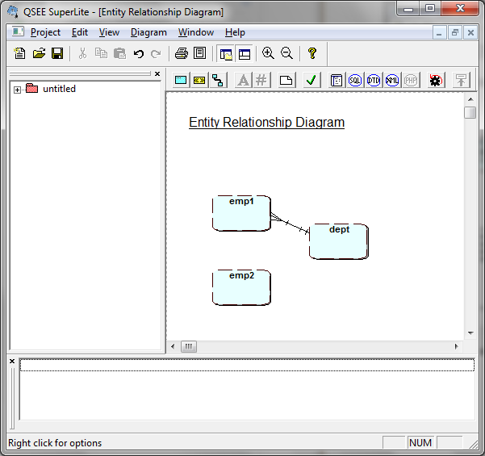

OLAP system

